A Brief Explanation on Evaluation Task 4 and Discussion Task 5 to help write the report.

Evaluation

Axis 1 Hypothesis: embeddings outperform TF-IDF producing clearer clusters.
Axis 2 Hypothesis: BERTopic gives more coherent and interpretable topics than LDA

Axis 1: Text Representation - TF-IDF vs Embeddings
To evaluate the performance of both approaches, we cluster them using K-mean at k = 15 as configured in the early stage, then find the SSE and Silhouette score to compare the performance. TF-IDF is treated as a baseline, in which it obtained the average Silhouette score of both languages at about 0.0475. On the other hand, Embeddings achieved an average score of about 0.088, meaning it performs better than our initial approach. The result makes sense since embedding can capture semantic meaning while TF-IDF only reflects the frequency and importance(rarity) of the words. To support this finding and investigate further, we also tried another clustering method, HAC, and calculated the Silhouette score. As a result, the average scores of TF-IDF in both languages and Embedding are about 0.015 and 0.066, respectively. This highlights the difference of performance between both approaches, with Embedding being the superior one. However, it is obvious that both Embedding and TF-IDF tend to have inferior performance for German. This is because……

Considering the robustness, Embedding obviously provides more consistency as Silhouette Scores are less fluctuated across K value, and although the “dog’s leg” is not clear for both approaches, Embedding’s line seems to be more curved while TF-IDF’s line is more linear. This finding aligns with our hypothesis.
For interpretability, we focus mainly on the English language and top 5 biggest cluster sizes. Top 10 words are found using c-TF-IDF. Although it is not clear which approach is outstanding, we found embedding easier to interpret and name a possible cluster group than TF-IDF.

Axis 2: Topic Modeling – BERTopic vs LDA
To evaluate the consistency of BERTopic and LDA, we investigate several results including,
LDA : Clustersize, Heatmap, Topic by type Compare+Explain results…
BERTopic: Clustersize, Heatmap, Topic by type Compare+Explain results…
We found the size of each topic for LDA is more balanced while BERTopic has a couple of topics with extremely large sizes and the rest are medium and small topic sizes. This is because….

BERTopic doesn’t seem to be that consistent (???), What about LDA??
For Coherence, …. (Explain using Coherence score along with other results)
In terms of Interpretability, … (Compare using Top words)

Discussion

Axis 1: Text Representation - TF-IDF vs Embeddings
As a result of the test in Axis 1, it is obvious to use Embedding instead of TF-IDF since it has better performance in every aspect. According to the plots of Silhouette scores against the value of K, TF-IDF’s scores are extremely fluctuated while Embedding’s scores are more stable. We also created elbow plots to find the “dog’s leg”, which is the point where the best value of K is located. For TF-IDF, both English and German, the lines seem to be linear while for Embedding, the lines appear more curved. Although there is no obvious point where SSE starts to stabilize, considering the elbow plots together with the Silhouette scores shows that Embeddings provides more consistency. This outcome is reasonable and as we expected. TF (Term Frequency) finds frequent words regardless of its meaning or importance, then IDF (Inverse Document Frequency) reduces the weight of words that appear in multiple documents, meaning the more documents each word occurs, the lower score it gets. This allows TF-IDF to reflect the importance of each word. And since it doesn’t capture any meaning, synonyms are totally unrelated and treated as 2 different things. TF-IDF also has many dimensions, creating sparse vectors which contain a lot of zeroes or near-zeroes. This becomes a problem when clustering as Euclidean distance might not effectively reflect semantic similarity between tickets. Embedding, in contrast, can capture semantic meaning and create dense vectors. It is a self-supervised learning which doesn’t require any human labels. Therefore, there are so many options of Embedding to be used whether it is training our own model or using a pre-trained model. We chose the pre-trained embedding model “paraphrase-multilingual-MiniLM-L12-v2”, a sentence transformer model or “SBERT”, which will be explained in the Axis 2 below.

Considering the clustering methods, we treated K-mean as our main method and HAC as a supplementary. K-mean is an unsupervised learning which uses Euclidean distance to determine which cluster each data belongs to, and the number of clusters must be defined before running. Each centroid is randomly located, and each data is assigned to the nearest centroid according to the Euclidean distance, creating K vectors containing the data in that cluster. The centroids are then recalculated to be the center of each cluster. This process continues until the centroids stop changing or until it reaches the number of attempts set.
HAC (Hierarchical Agglomerative Clustering) starts by merging the two closest points into a cluster, then that cluster is treated as a new data point. This process continues until all data points are merged, resulting in a big single cluster. The method we used to find which clusters should be merged is Ward linkage. It decides based on variance with the goal of trying to minimize the variance within the cluster[Ref WardLinkage].

Axis 2: Topic Modeling – BERTopic vs LDA
BERTopic is basically a pipeline consisting of SBERT(Sentence Embedding), UMAP(Dimensionality Reduction), HDBSCAN(Clustering), CountVectorizer, and c-TF-IDF. As we mentioned “SBERT” earlier in Axis 1, it transforms sentences rather than words into dense vector representations, supporting multiple languages although they might not perform as good as English due to the limited training data [REF Sentence Transformer]. UMAP (Uniform Manifold Approximation and Projection for Dimension Reduction) is a non-linear Dimensional Reduction method while HDBSCAN is a clustering algorithm applied on the output from UMAP. The top words in each cluster are then found using c-TF-IDF (​​Class-based Term Frequency Inverse Document Frequency), which works the same way as TF-IDF, but operates at the cluster-level rather than document-level[Ref c-TF-IDF]. The advantage of BERTopic is the interpretability of the topics[REF BERTopic], and it is the reason why BERTopic is chosen.
LDA or Latent Dirichlet Allocation is a probabilistic model that finds the hidden topics. The core idea of LDA is that the documents are the mixture of topics while topics are the mixture of words, with the aim to compute the topic proportion in each document [REF LDA]. It uses bag-of-words representations, which means it doesn’t capture any semantic meaning like BERTopic.
Advantage of BERTopic vs LDA … why we choose BERTopic

interpretation is subjective and can vary between people(?)

Mention Reproducibility issue different OS, slightly different results

Reference:
Ward Linkage:
https://medium.com/@sujathamudadla1213/discuss-the-concept-of-ward-linkage-in-hierarchical-clustering-e97c49989130
Access 10 April 2026
c-TF-IDF:
https://medium.com/@shashankag14/understanding-tf-idf-and-c-tf-idf-in-topic-modeling-071eb82fa858
Access 10 April 2026
Sentence Embedding Model
https://huggingface.co/sentence-transformers/paraphrase-multilingual-MiniLM-L12-v2
Sentence Transformer
https://www.geeksforgeeks.org/nlp/sentence-transformer/
SBERT
https://www.sbert.net/
BERTopic
https://huggingface.co/docs/hub/bertopic
LDA
https://www.geeksforgeeks.org/nlp/topic-modeling-using-latent-dirichlet-allocation-lda/

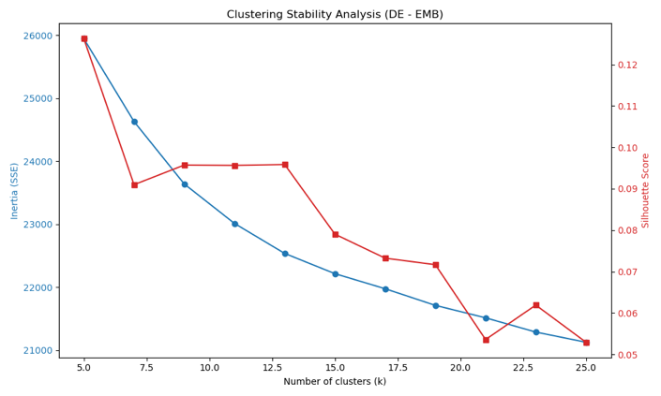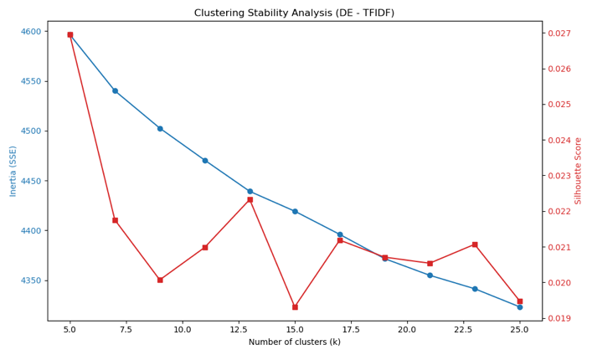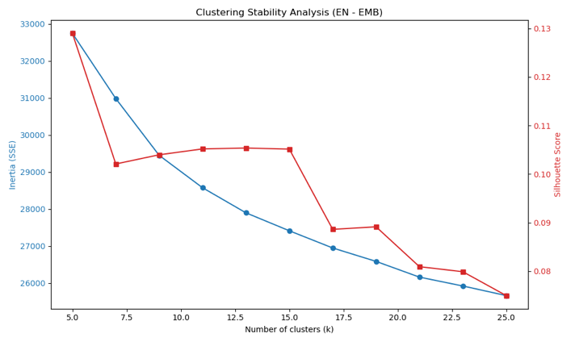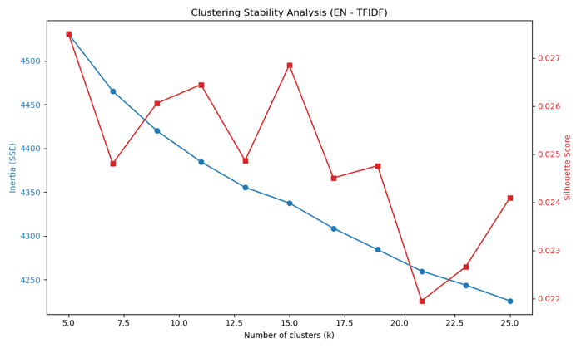
BERTopic
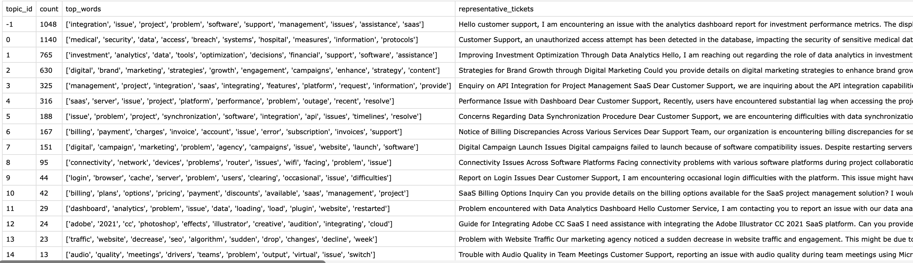
LDA
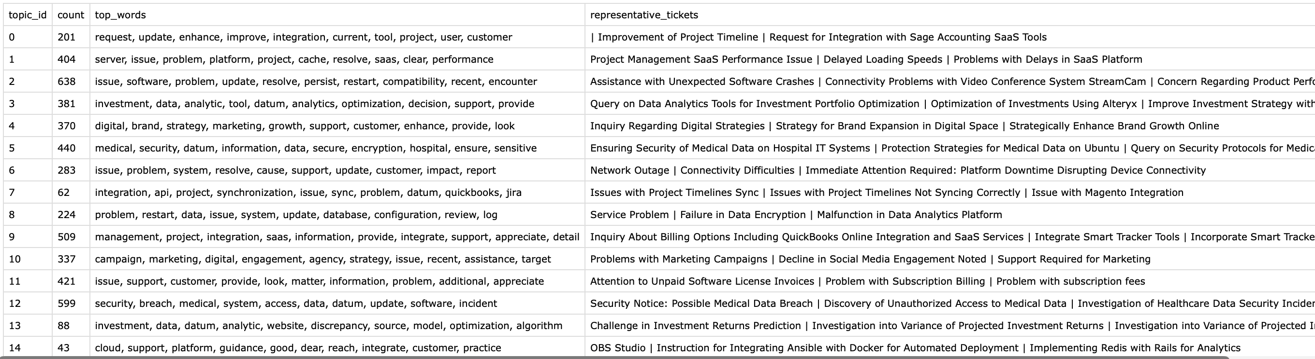
Embedding
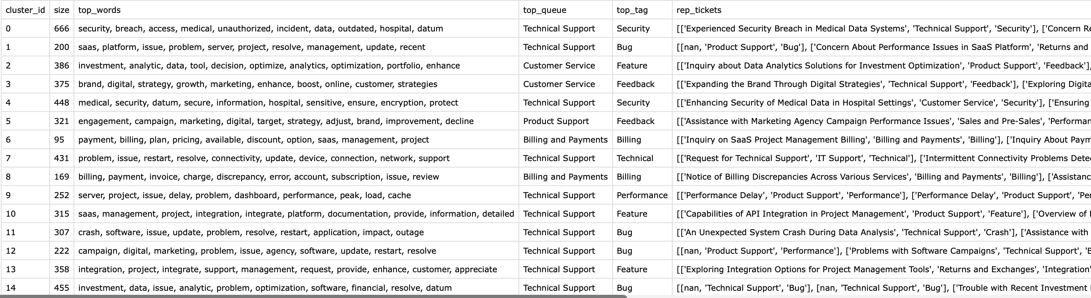
TF-IDF
